***Cells Alive!***

Visit the Cells Alive! website at the URL below. Follow the instructions to complete the checklist for each activity. Don’t forget to click on each box in the check list as you complete it.

[www.cellsalive.com](http://www.cellsalive.com)

**Activity 1: Organelles in Animal and Plant Cells**

Under Interactive Cell Models, click on the Plant/Animal link, then click on the red button labelled “Start the Animation”

Choose either the animal cell or the plant cell (in green writing under the black box).

Hover over organelles in the cell to bring up the name of the organelle. Click on the organelle to reveal its function.

Label the diagram of the **animal** cell in this document showing the name of each organelle and the function of the organelle (click on each text box and type into it)

Label the diagram of the **plant** cell in this document showing the name of each organelle and the function of the organelle (click on each text box and type into it)

**Activity 2: Memory Match**

Return to the Cells Alive! homepage and click on the “Match, Jigsaw and Crossword” link under Cell Puzzles and Games

Find the Memory Match games and click on the “Cell Organelle Match” link.

Complete the “Cell Organelle Match”.

Take a screenshot of your completed “Cell Organelle Match” puzzle and insert the screenshot on the final page of this document, after the cell diagrams.

**Activity 3: History of Microscopy**

Return to the Cells Alive! homepage and click on the “Microscopy Methods” link under Microscopy.

Click on the hyperlink to the “New York Times’ animated video” about Antoine Van Leeuwenhoek. (also available at <https://www.youtube.com/watch?v=ePnbkNVdPio> )

Watch the video and answer the questions on the next page.

**Video Questions**

1. What was Antoine Van Leeuwenhoek’s job and in which city did he live? (1:12)
2. How many microscopes did Leeuwenhoek construct? (1:27)
3. Which English scientist wrote a book based on his observations with lenses, and what was the name of the book? (1:32)
4. When he looked at the same objects, what advantage did Leeuwenhoek have over Robert Hooke? (1:50)
5. List 5 organisms Leeuwenhoek saw when he looked at the pond water through his lenses. (2:18)
6. What are some other things Leeuwenhoek discovered using his microscopes? (3:53)
7. How do micro-organisms help humans to survive? (4:30)
8. What are *vibrio harveyi*? What does ‘vibrio’ in their name mean? (4:45)
9. What is unique about these bacteria when the multiply? (5:03)
10. What do we now now about bacteria from studying *vibrio harveyi*? (5:12)

**Activity 4: Photomicrography**

Go to the Nikon Small World website <https://www.nikonsmallworld.com/>

Scroll down to Photomicrography Competition and click on the “Browse the Photo Galleries” link.

Click on the 2019 Winners and look through the photos.

Choose your favourite 3 photos and write the details of the photos below.

|  |  |  |  |
| --- | --- | --- | --- |
| **Photo** | **Photographer** | **Technique** | **Magnification** |
|  |  |  |  |
|  |  |  |  |
|  |  |  |  |

**Label each organelle in the animal cell and briefly describe its function.**

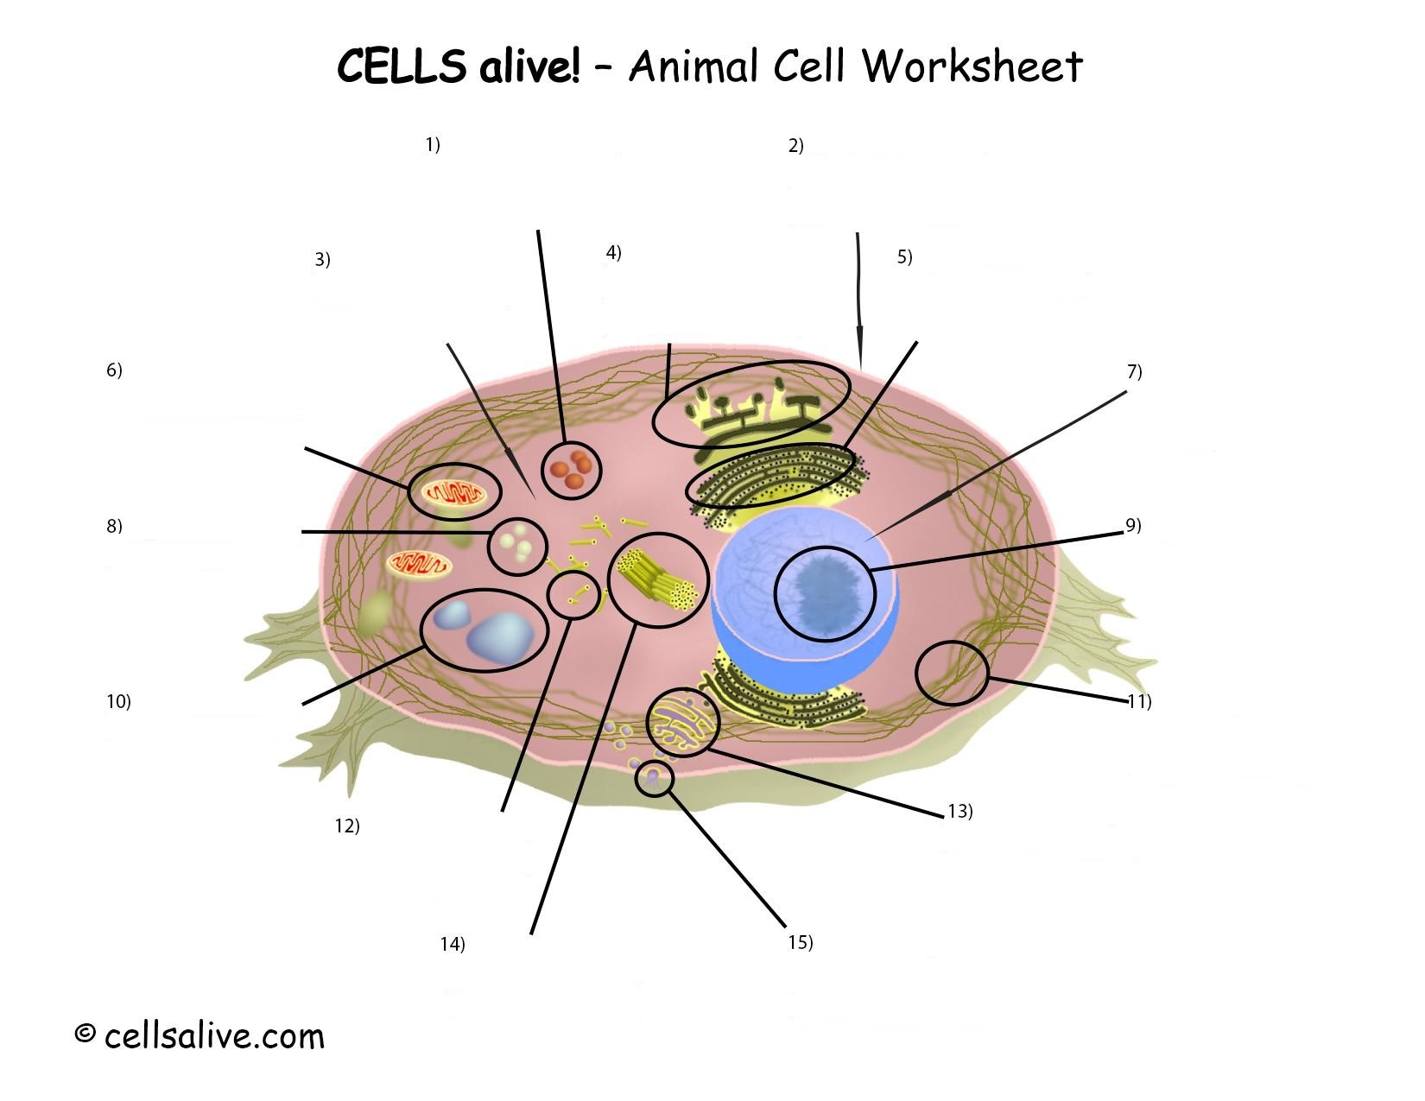

**Label each organelle in the animal cell and briefly describe its function.**

